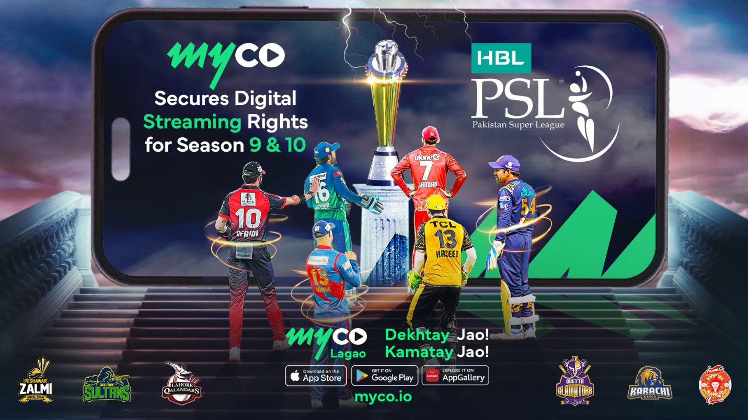

Headlines
Revolutionizing Cricket Viewing: myco Secures digital streaming rights for HBL PSL Season 9 & 10

Press release

Highlights:
- myco Secures PSL Streaming Rights: myco, a global blockchain-based video streaming platform, has obtained digital streaming rights for the HBL PSL Seasons 9 & 10, aiming to transform digital sports streaming.
- "Watch & Earn" Model: Viewers can watch HBL PSL matches in HD for free on myco and earn from the advertising revenue generated, thanks to the platform's innovative "Watch & Earn" model, which rewards viewers based on their watch time.
- Easy Earnings Withdrawal: Through integration with Simpaisa, myco's payment partner, users can conveniently withdraw their earnings directly to over 35 bank accounts and all major digital wallets in Pakistan, making the rewarding experience seamless.
- Global Impact and Local Presence: myco's success, highlighted during the ICC World Cup 2023, has established it as a preferred platform for cricket streaming globally and in Pakistan. With partnerships across various sports and a content library exceeding 500,000 items, myco serves a global audience while maintaining a strong local commitment.
- Dedication to empowering viewers globally: myco is focused on leveraging its global success to enrich the local content economy, bringing premium sporting events and entertainment to viewers.

In a groundbreaking move, myco, the global blockchain-based video streaming platform, has secured the coveted digital streaming rights for HBL PSL Season 9 & 10. This milestone not only reshapes the landscape of digital sports streaming but promises an unparalleled cricket viewing experience for fans in Pakistan.

Empowering viewers
Cricket enthusiasts can now enjoy the thrilling HBL PSL matches in HD for free on myco. The platform's unique "Watch & Earn" model elevates the viewer experience by allowing them not only to enjoy the game but also empowers viewers to earn based on their watch time. Engaged viewers become stakeholders in the advertising revenues generated by the platform, delivering an interactive and rewarding experience to sports viewing.

Seamless Integration with Simpaisa for Reward Withdrawals
The integration with myco’s payment partner, Simpaisa, enhances the unique "Watch & Earn" model where users can easily withdraw their earnings directly into 35+ bank accounts and all major digital wallets in Pakistan, adding a seamless and convenient aspect to the rewarding experience.

myco's Impact on Global Cricket Streaming
The success trajectory of myco gained momentum during the ICC World Cup 2023, where it emerged as the preferred choice for cricket enthusiasts. Trending at the top positions on both app stores and play stores, myco distributed over 20 million PKR worth of advertising revenue to more than 250,000 highly engaged viewers. The platform continues with its streaming of various cricket leagues in Pakistan & globally, including ILT20, SAT20, and SPL. Myco boasts a rich history of collaborations, having partnered with PCB, English Premier League, and the Emirates Cricket Board, as well as major squash, tennis, and racing festivals worldwide.

A Global Platform with a Local Heart
With a global presence spanning 204 countries and a user base exceeding 6.5 million registered users, myco offers an extensive library comprising over 500,000 content items, ranging from documentaries and films to a diverse array of creator and influencer partnerships, alongside live sports.

Somair Rizvi, Co-Founder & COO myco, expressed his enthusiasm, stating, "We are committed to bringing premium sporting events and content libraries to our Pakistani viewers. This move strengthens our dedication to providing top-notch quality entertainment while empowering our viewers to have a sustainable stake within the content economy both from a financial and creative standpoint.”

About PSL 9:
The 2024 Pakistan Super League (PSL 9) will span 31 days, starting on February 17 and concluding on March 18, with a total of 34 matches scheduled across four venues: Karachi (11 matches), Lahore and Rawalpindi (9 matches each), and Multan (5 matches). While specific global viewership estimates for PSL 2024 are not provided, the league's popularity is evident from past performance, with significant increases in sponsorships and broadcasting rights indicating a wide audience reach. For instance, previous seasons have seen a substantial surge in viewership, with some platforms reporting over 200 million views in just the first 12 days of the season, highlighting the league's broad appeal and growing fan base in Pakistan and Globally.

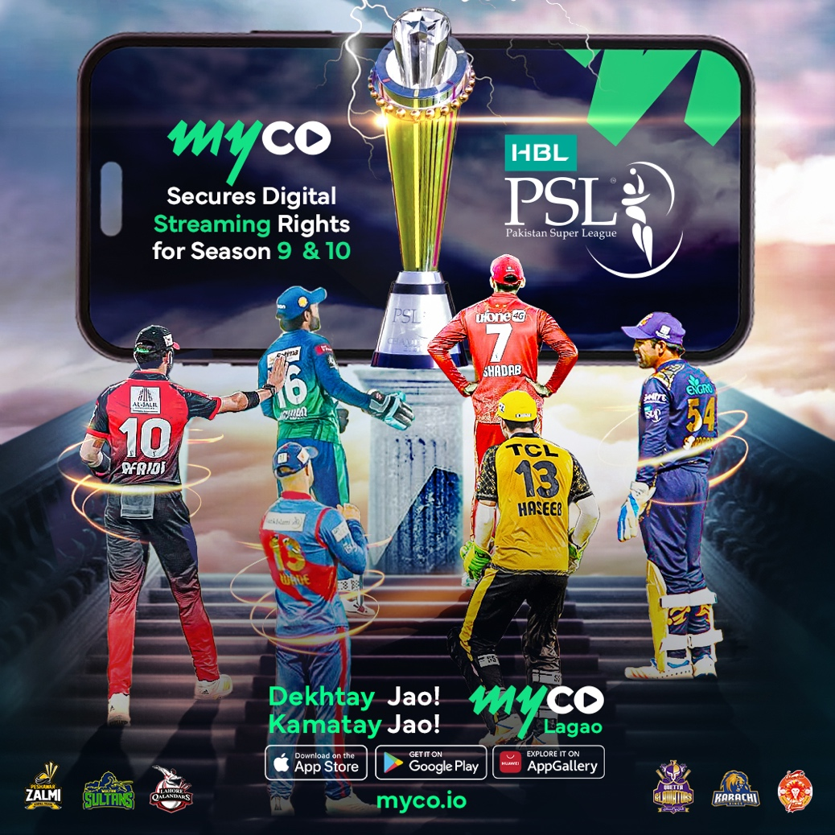

www.myco.io
Download the app from your
favorite App store

About myco
myco is a web3 video streaming platform where SVOD and AVOD capabilities have been vertically integrated in a decentralized environment. The myco platform empowers viewers and creators in a fully decentralized video eco-system with live monetization, crowdfunding, gating NFTs and fractional ownership of content. The myco platform has over 6 million registered users from across the globe with major footprint in MENA, North America and Soth Asia, 1,500 leading content creator channels, and more than 500,000 user generated videos, as well as a collection of 50 myco original productions and 1,000 hours of premium exclusive content. Recently myco disrupted the sports streaming space by become the first to offer exclusive live sports in a watch&earn model with participation from top global brands as advertising partners.

For more information contact:

Tariq Jaser
Head of Marketing
tariq@myco.io

